CSCI 485 Assignment 2
Ian Nevills

1)
The difference between user mode and kernel mode, as I understand it, comes down to a matter of permissions. Most essential processes, such divers and the operating system work in kernel mode where they can directly interface with the hardware. Applications are run in user mode and have no access to the hardware directly or have the ability to reference memory. The benefit to both is to essentially isolate the user from the hardware so they can't accidentally destroy their machine.

2)
.4*.4*.4*.4*.4*.4*.4=.0016384
1-.0016348=.9983616

3)If the two processes run in sequence then they should take 40 minutes to complete, as each will run to completion. If they run in parallel then they will take around 20 minutes to complete if the I/O utlilization is 50%, one will run while the other waits.

4)
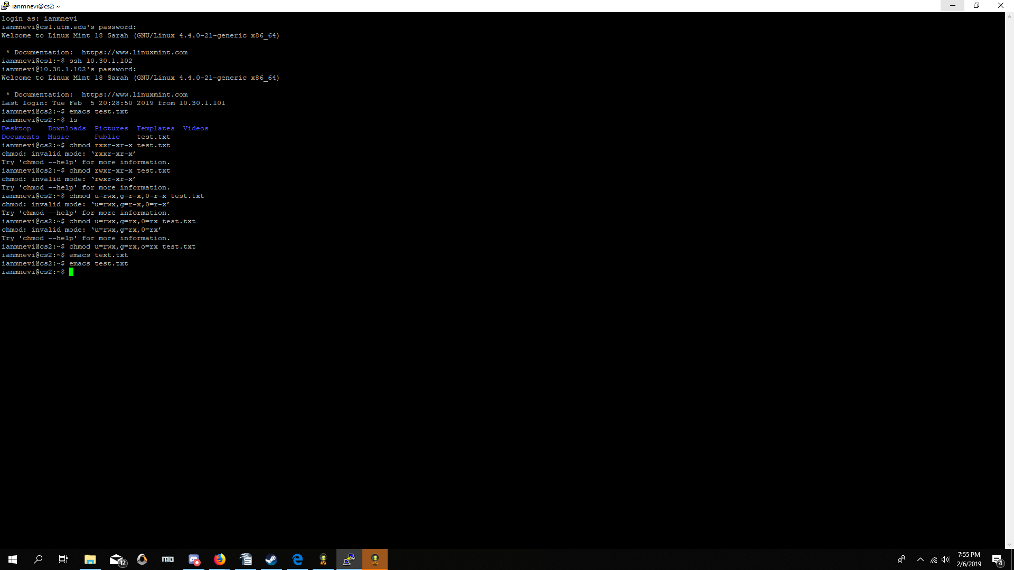
Can edit

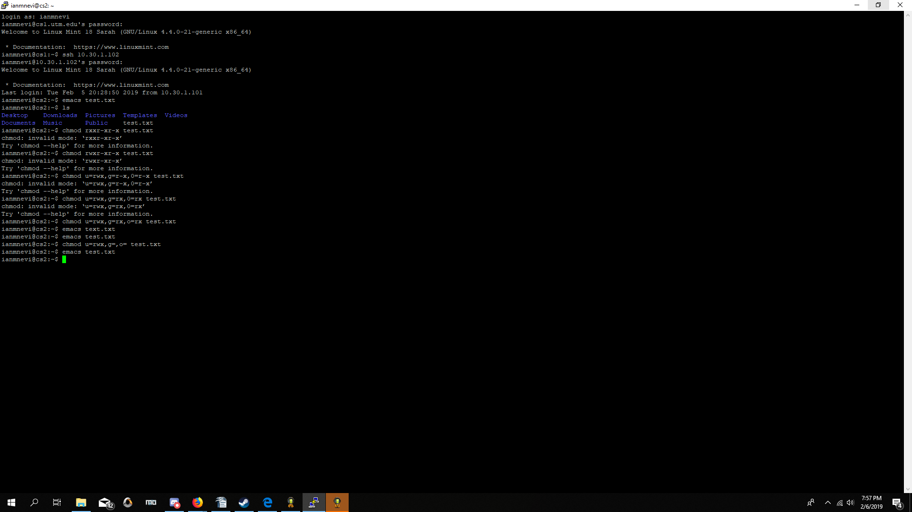
can edit

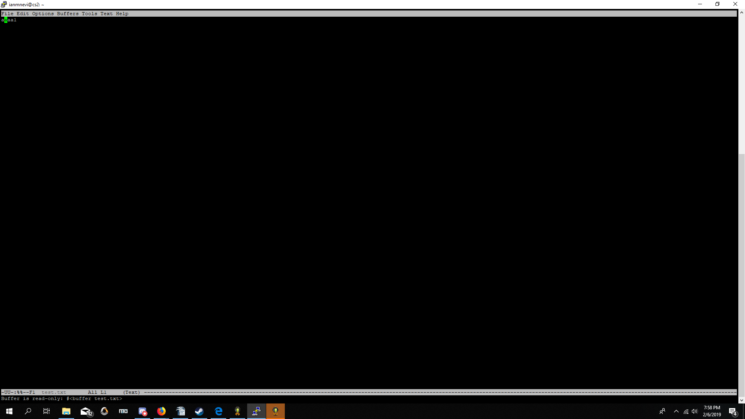
Buffer is read only on the last set
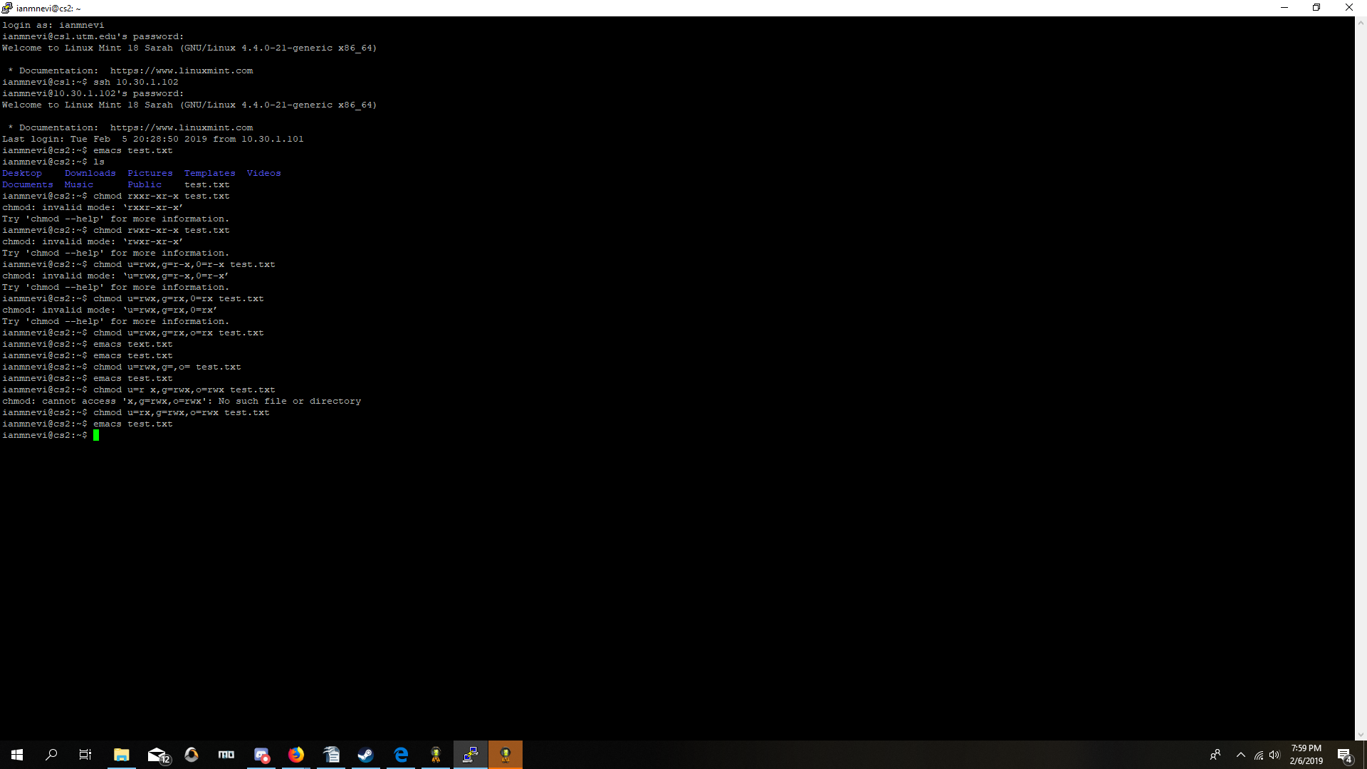
5)
Kernel level threads may get more time to process if they have a large number of threads, but are inefficient compared to user level threads and are on the whole much slower. Kernel threads also require a thread control block for each thread to maintain information so there is a much greater degree of overhead and increased complexity.

User level threads are much faster and more efficient as well as are much simpler to manage as they don't need the kernel to intervene when switching. User level threads don't integrate or communicate well with the OS, so the scheduler is imperfect when using them and can make mistakes. Also, given the lack of communication, all user level threads are given the same amount of time regardless of the actual number of threads.

6)
Disabling interrupts for MUTEX makes it so that the program will never be interrupted by the clock and will continue until it is out of the critical region as the CPU never switches, but problems occur if the software never reenables interrupts and so the CPU never switches and nothing more gets done as a result. The computer is essentially frozen at this point.

7)
The Lock Variable solution needs to be converted to strict alternation because the lock variable method can be "intercepted" before the function can lock the critical region and so two or potentially more can end up in the critical region with out it actually being locked. Strict alteration forces one to be in its critical region at a time and requires the switching to continue functioning.

